

Lab Documentation

in course

Autonomous Systems:   
Path Planning   
and   
Control

Professor: Prof. Dr.-Ing. Frank Tränkle

Students:

|  |  |  |  |
| --- | --- | --- | --- |
| Name: | Aaron Kiani | Matrikelnummer: | 903225 |
| Name: | Heiko Wascheck | Matrikelnummer: |  |

Winter semester 2023/2024

Deadline: 16.01.2024

# Table of Contents

Table of Contents 2

1. Vehicle Dynamics Simulation 3

a) Low-Speed Controller: Signal-Time diagram of step response of vehicle speed 𝑣 3

b) High-Speed Controller: Signal-Time diagram of step response of vehicle speed 𝑣 3

c) Signal-Time diagram of step response of yaw angle 𝜓 4

2. Speed Control 5

a) Mathematical expressions and values for values of 𝑇𝑖 and 𝑘𝑟 5

b) Bode diagram of including margins 6

c) Signal-Time diagram of step response 7

d) Transfer function 𝐺𝑅∗(𝑧) of discrete-time PI controller 7

e) Differences equations to compute I part 𝑢𝑖𝑘 = 𝑢𝑖(𝑘𝑇𝐴) and total manipulation signal 𝑢𝑘 =𝑢(𝑘𝑇𝐴) from control deviation 𝑒𝑘 = 𝑤𝑘 – 𝑦𝑘 7

3. Longitudinal Position Control 8

a) Mathematical expressions for 𝑌𝑝(𝑠), 𝐸𝑝(𝑠), 𝑒𝑦, 𝑘𝑝 8

b) Signal-time-diagram of response 𝑦𝑝(𝑡) to 𝑤𝑝(𝑡) = 𝑣∗𝑡ℎ(𝑡) 8

c) Root locus curves of control loop in dependence of 𝑘𝑝 9

d) MATLAB functions cd_refpoly_vmax and cd_refpoly_ff 10

e) Signal-time-diagrams of 𝑤𝑝(𝑡), 𝑦𝑝(𝑡), 𝑤̇ 𝑝(𝑡), 𝑤̈ 𝑝(𝑡) and 𝑢𝑉𝑝1(𝑡) 11

f) Discrete-time transfer function of high-pass filter of feed-forward controller 13

g) Differences equation of manipulation signal in dependence of 13

h) Extended MATLAB script ex6_1.m containing the solutions of the individual exercise and test the programmed MATLAB functions 13

i) Signal-time-diagrams of reference position 𝑤𝑝(𝑡) and actual position 𝑦𝑝(𝑡) = 𝑥(𝑡) from MiL and real drive tests 14

4. Extended Exercises - 20.4 Reference Path Following in Emergency Halts 15

# Vehicle Dynamics Simulation

The figures in a) and b) result from giving a step signal into the vehicle dynamics system with a step time of one second. For the speed v the motor step signal *pedals* is set to 0.05 to trigger the Low-Speed Controller. For triggering the High-Speed Controller, *pedals* is set to 0.1. In the figure the switch from Low to High-Speed Controller is visible after approx. 1.6 seconds which leads to a very short sharp, jagged fluctuation. This arises because of the different equations used in the controller and therefore a sudden discontinuous change of *caroutputsext.*

## Low-Speed Controller: Signal-Time diagram of step response of vehicle speed 𝑣

*Figure 1: Low-Speed Controller: Signal-Time diagram of step response of vehicle speed 𝑣*

## 

## High-Speed Controller: Signal-Time diagram of step response of vehicle speed 𝑣

## 

*Figure 2: High-Speed Controller: Signal-Time diagram of step response of vehicle speed 𝑣*

## Signal-Time diagram of step response of yaw angle 𝜓

Giving a step signal of 0.7 in the steering angle *steering* results in the rising yaw angle 𝜓 which leads to the car driving in a sharp circular path (first diagram). In the second diagram the step signal is set to 0.2 which leads to a flatter rising curve and to a wider circular path.



Figure : Signal-Time diagram of step response of yaw angle 𝜓

# Speed Control

## Mathematical expressions and values for values of 𝑇𝑖 and 𝑘𝑟

**𝑇𝑖:**

Open Loop Frequency Response:

General Open Loop Phase Response:

Phase Margin:

Solve with MatLab fzero() for 𝑇i with and

**𝑘𝑟:**

General Open Loop Magnitude Response:

with Magnitude Response at Crossover Frequency :

and therefore solved for :

## Bode diagram of including margins

Ein Bild, das Text, Reihe, Diagramm, parallel enthält.
Phase Margin: 62.56°  
Gain Margin: 4.76  
Phase Crossover Frequency: 3.56 rad/s

Figure : Bode diagram of including margins

## Signal-Time diagram of step response

Figure : Signal-Time diagram of step response

## Transfer function of discrete-time PI controller

## Differences equations to compute I part 𝑢𝑖𝑘 = 𝑢𝑖(𝑘𝑇𝐴) and total manipulation signal 𝑢𝑘 =𝑢(𝑘𝑇𝐴) from control deviation 𝑒𝑘 = 𝑤𝑘 – 𝑦𝑘

Ich hab das nicht: Das hast du auf deinem Block gemacht Heiko. Glaub ich zumindest.

## Signal-Zeit-Diagramme von Sprungantworten der Fahrzeuggeschwindigkeit vr aus Simulink-MiL-Simulationen und auf dem realen MAD-System

# Longitudinal Position Control

## Mathematical expressions for 𝑌𝑝(𝑠), 𝐸𝑝(𝑠), 𝑒𝑦, 𝑘𝑝

## Signal-time-diagram of response 𝑦𝑝(𝑡) to 𝑤𝑝(𝑡) = 𝑣∗𝑡ℎ(𝑡)

Ein Bild, das Text, Reihe, Diagramm, Zahl enthält.

Figure : Signal-Time Diagram of the cascade control loop

## Root locus curves of control loop in dependence of 𝑘𝑝

The first figure shows the root locus curve of the closed control loop as a function of kp=1. In this case, all poles are negative, indicating a stable control loop. In the second case, kp is set to 7.5, which makes the poles almost positive, and thus the control loop would be unstable.

Ein Bild, das Text, Diagramm, Reihe, Zahl enthält.

Ein Bild, das Text, Diagramm, Reihe, Zahl enthält.

Figure : Root locus curves of the control loop in dependence of 𝑘𝑝 with values  
kp = 1 and the last possible value kp = 7.5 maintaining system stability.

## MATLAB functions cd_refpoly_vmax and cd_refpoly_ff

The functions can be found in the corresponding files:

* cd_refpoly_vmax.m
* cd_refpoly_ff.m

## Signal-time-diagrams of 𝑤𝑝(𝑡), 𝑦𝑝(𝑡), 𝑤̇ 𝑝(𝑡), 𝑤̈ 𝑝(𝑡) and 𝑢𝑉𝑝1(𝑡)

Ein Bild, das Text, Diagramm, Reihe, Screenshot enthält.

Figure : Signal-Time diagram of wp(t) and yp(t) without feedforward

Ein Bild, das Text, Diagramm, Reihe enthält.

Figure : Signal-Time diagram of the first derivative wp*(t)

Ein Bild, das Text, Diagramm, Reihe, Zahl enthält.

Figure : Signal-Time diagram of the second derivative wp**(t)

Ein Bild, das Reihe, Text, Diagramm, Zahl enthält.

Figure : Control signal for feedforward

Ein Bild, das Text, Diagramm, Reihe, Zahl enthält.

Figure : Comparison of wp(t) and yp(t) with active feedforward

Ein Bild, das Text, Reihe, Diagramm, Screenshot enthält.

Figure : Zoomed comparison of wp(t) and yp(t) with active feedforward

From the different diagrams the computed polynomials and their derivatives. Applying the high-pass filter of the feed-forward controller leads to almost non-existing offset between and .

## Discrete-time transfer function of high-pass filter of feed-forward controller

Apply Trapezoidal rule:

Trapezoidal rule inserted in and shortened yields:

Substituting the values into the equation yields:

## Differences equation of manipulation signal in dependence of

Multiplying and solving the brackets in the equation yields:

Numerator:

Denominator:

## Extended MATLAB script ex6_1.m containing the solutions of the individual exercise and test the programmed MATLAB functions

Solutions are in the lower part of file ex6_1.m in *HS_Path_Planning_and_Control/*

## Signal-time-diagrams of reference position 𝑤𝑝(𝑡) and actual position 𝑦𝑝(𝑡) = 𝑥(𝑡) from MiL and real drive tests

Ich glaube nicht dass das stimmt 🡪 sollten fast aufeinander sein…

# Extended Exercises - 20.4 Reference Path Following in Emergency Halts

Task description

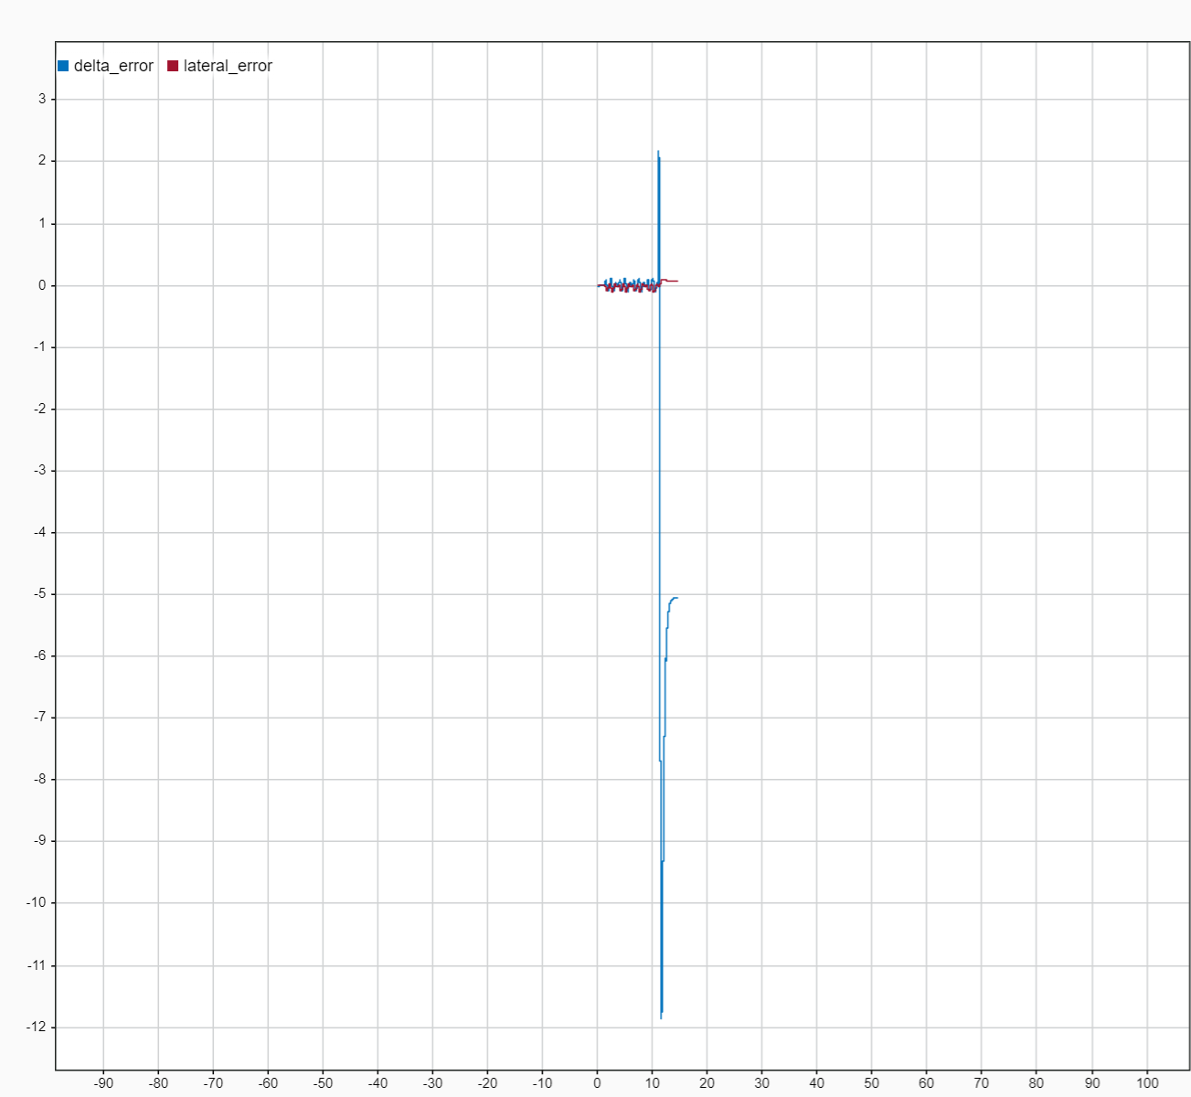If the car is travelling at a high speed such as 1.5 m/s on the track and is stopped quickly, the lateral distance error of the car increases extremely and the car does not come to a stop in the middle of the track. This sensation can occur when the car initiates emergency halt. This’s shown in the Image XX below, the *delta_error* is extremely high.

This problem can be seen both in the simulation and in the real system.

The task of this exercises is, to fix this issue. In the end, the lateral distance error of the path following controller must be less than 1 cm in case of an emergency halt.

Solution of the tasks

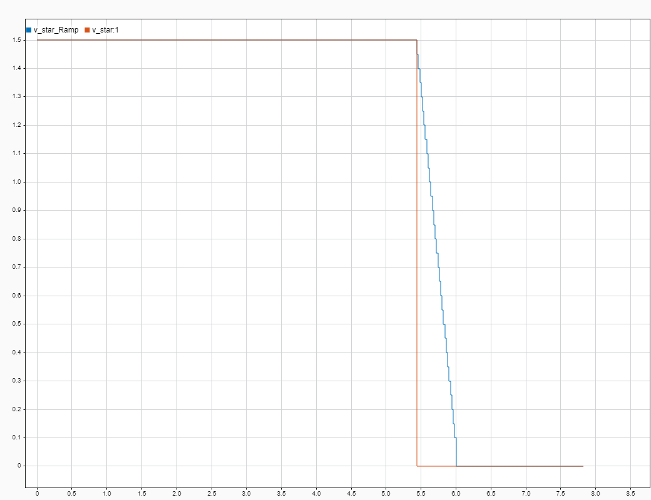A closer look at the task shows that as soon as a high impulse response of the velocity is to be converted (0.5 or higher to zero), these outliers occur. To solve this problem, a ramp is implemented that maps the high speed to zero as a ramp signal instead of a jump. This ramp is implemented in the file *s7_tamplate_extra.slx* and can be found at the following path *s7_tamplate_extra -> Control Software -> Path Controller -> FB – Non-linear Feedback-Controller.* In the following image you can see the ramp-signal and the jump (picture XX).

The diagram of the *delta_error* and the *lateral_error* after implementation of the ramp function can be seen in figure XX. There you can see that the extremely high spike has disappeared.

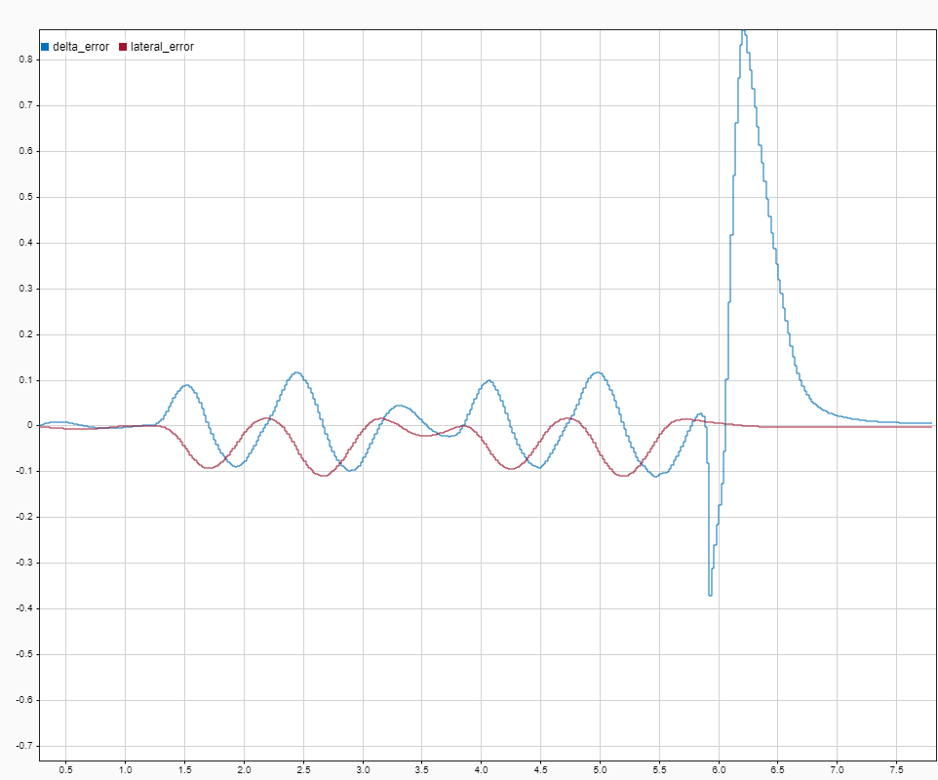

Further proof that the built-in function works can be seen in the car in the simulation. In both cases, the car starts at 1.5 m/s and performs an emergency stop at approximately the same point (the speed is abruptly set to 0), bringing the car to a standstill. Here (see Figure XX left), without using the ramp response, it can be seen that the car has an orientation at the end that does not follow the path due to an abrupt stop and the lateral distance error is verry high. However, with the implementation of the ramp response, the vehicle shows that after it has come to a standstill, it is still heading in the direction of the track (see Figure XX right) and the lateral distance error is very small.

Ein Bild, das Screenshot, Rechteck, Text, Design enthält.
